**Assembly Lab Assignment 3**

1. Write an Assembly Language Program to find the smallest number from a series of

seven data bytes stored from DS: 0030H. Store the smallest number in DS: 0040H.

**Code:**

.model small

.stack 100h

.data

.code

main proc

mov ax, @data

mov ds, ax

mov cl, 07h

mov al, 00ffh

mov si, 0030h

l1:

cmp al,[si]

jc l2

mov al, [si]

l2: inc si

loop l1

mov si, 0040h

mov [si], al

int 03h

mov ah, 4ch

int 21h

main endp

end main

**Output:**

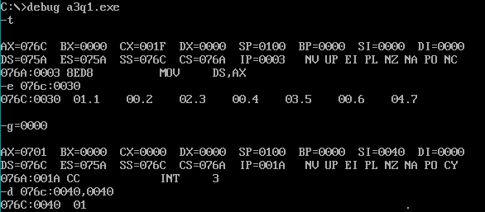

—-----------------------------------------------------

1. Write an Assembly Language Program to find the largest number from a series of 7

sixteen-bit numbers stored from DS: 0030H. Store the largest number in DS: 0040H.

**Code:**

.model small

.stack 100h

.data

.code

main proc

mov ax, @data

mov ds, ax

mov cx, 0007h

mov ax, 0000h

mov si, 0030h

l1: cmp ax, [si]

jnc l2

mov ax, [si]

l2: add si, 02h

loop l1

mov si, 0040h

mov [si], ax

int 03h

mov ah, 4ch

int 21h

main endp

end main

**Output:**

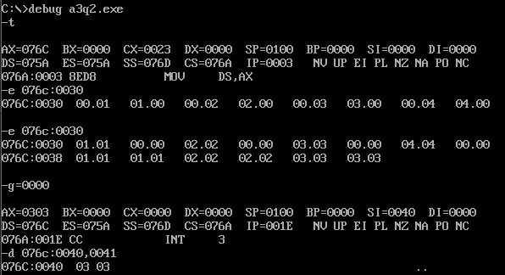

1. Write an Assembly Language Program to arrange a series of 7 data bytes stored from

DS: 0030H in ascending order.

**Code:**

.model small

.stack 100h

.data

.code

main proc

mov ax, @data

mov ds, ax

mov si, 0030h

mov bl, 06h

l3:

mov si, 0030h

mov cl, 06h

l1:

mov al, [si]

inc si

cmp al, [si]

jc l2

mov dl, [si]

mov [si], al

dec si

mov [si], dl

inc si

l2: loop l1

dec bl

cmp bl, 00h

jnz l3

int 03h

mov ah, 4ch

int 21h

main endp

end main

**Output:**

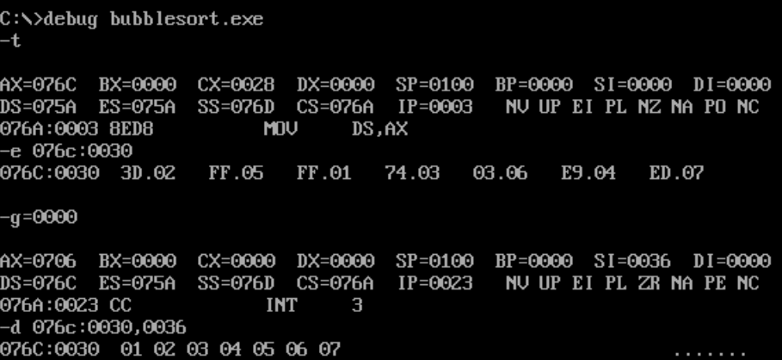

1. Write an Assembly Language Program to arrange a series of 7 sixteen-bits data stored

from DS: 0030H in descending order.

**Code:**

.model small

.stack 100h

.data

.code

main proc

mov ax, @data

mov ds, ax

mov si, 0030h

mov bl, 06h

l3:

mov si, 0030h

mov cl, 06h

l1:

mov ax, [si]

add si, 02h

cmp ax, [si]

jnc l2

mov dx, [si]

mov [si], ax

sub si, 02h

mov [si], dx

add si, 02h

l2: loop l1

dec bl

cmp bl, 00h

jnz l3

int 03h

mov ah, 4ch

int 21h

main endp

end main

**Output:**

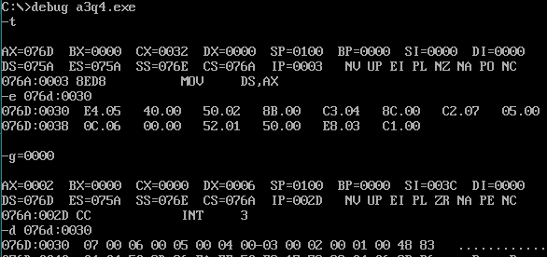

1. Write an Assembly Language program to find the square of a number stored in DS:

0030H using LOOK-UP table. Assume that the LOOK-UP table is stored from DS:

0040H that contains the square of the numbers 0 to 9. Store the square value in DS:

0050H.

**Code:**

.model small

.stack 100h

.data

.code

main proc

mov ax, @data

mov ds, ax

mov si, 0030h

;mov bl, [si]

;mov bh, 01h

;mov al, [bx]

mov al, [si] ; taking input in al

mov bx, 0100h ; moving to starting address of lookup table

xlat

mov si, 0040h

mov [si], al

int 03h

mov ah, 4ch

int 21h

main endp

end main

**Output:**

